**Ideation Phase**

**Brainstorm & Idea Prioritization Template**

|  |  |
| --- | --- |
| Date | 13 October 2022 |
| Team ID | PNT2022TMID18635 |
| Project Name | Containment Zone Alerting Application |
| Maximum Marks | 4 Marks |

# Containment Zone Alert Application – Brainstorming & Idea Prioritization

Step-1:

Team Gathering, Collaboration and Selecting the Problem Statement Step-2:

Brainstorming, Idea Listing and Grouping Step-3:

Idea Prioritization

**IDEA:**

The app should have a user registration and login.  After the user logged into the app it will  track the user's location and update the database with the current location.  If the user is visiting the containment zone he will get an alert notification.

They should login to the app and update the containment zones locations in the portal. Based on the location a Geofence will be created within a 100 meters radius. They should be able to see how many people are visiting that zone.

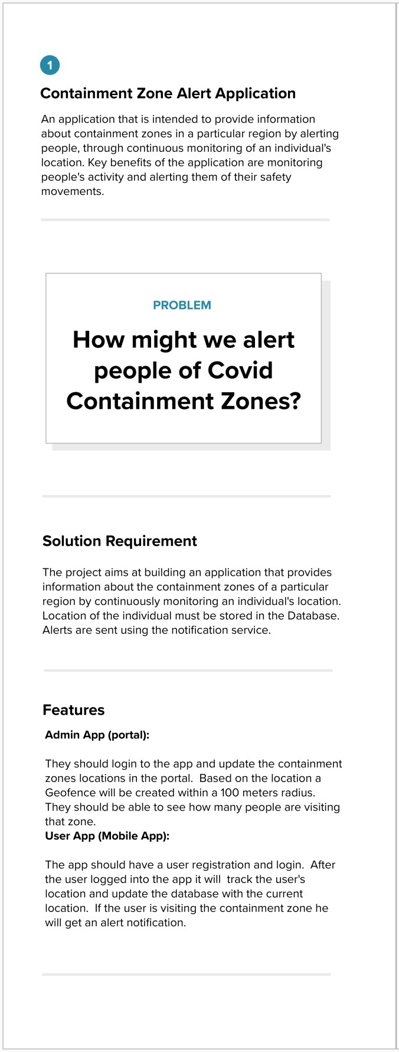

# Team Gathering, Collaboration and Selecting the Problem Statement

**Brainstorming, Idea Listing and Grouping**

TEAM IDEA WORKSPACE

GOAL

Containment Zone Tracking Application Development

FAVOURITE IDEAS

This application is intended to provide information about containment zones in a particular region by alerting people, through continuous monitoring of an individual’s location. Key benefits of the application are monitoring people’s activity and alerting them of their safety movements

COMMENTS

CONSTRAINTS

Not too much colloborations

Maintain necessary data’s access necessary usage of location

There is a way to share your location to your saved contacts

Make profit as public to alert nearby user whether they are affected or not?

User can contact the war room service for their Emergency purposes

We can send grid type of alert messages

User can access the nearby pharmacy with limited no of tablets w/o doctor prescription

For the affected person profile, user can contact the Emergency services

User must keep updated of their app for better reliable of data

User can share their status as public whether they are affected or not

**Gowtham R**

User can see the updated alert zones before moving to the destination point

We must develop both web & mobile application for the various kinds of users

If the person encountered into the marked zones the alert messages are sent via mail

**Mohanaraman VS**

The alert messages should be some interactive

Can we send the alert messages through App notification

If we want to push the notification we need to provide the alerted zones

How can we push the notification to the user

**Gobikrishnan R**

We need to access the location while to see the alerted zones

And they provide correct infos native zones

We might face lot of challenges

For the precise use of location and get prior alert messages

**JayaSurya C**

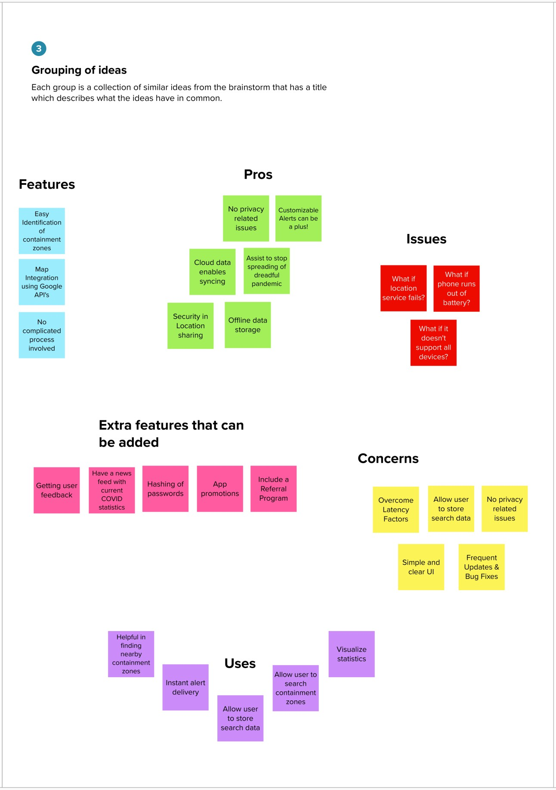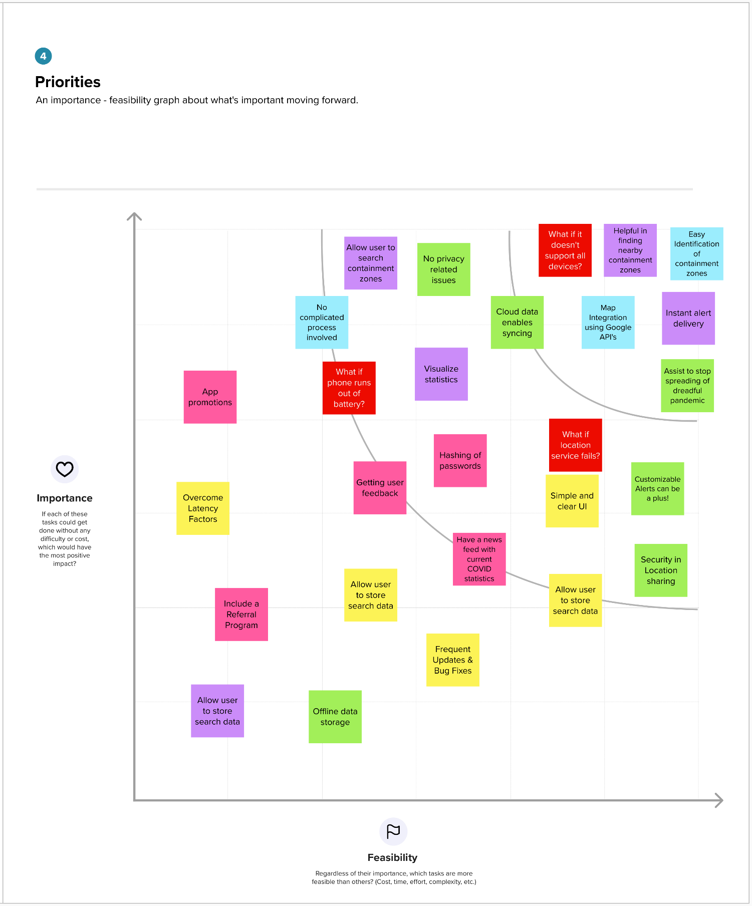

# Idea Prioritization